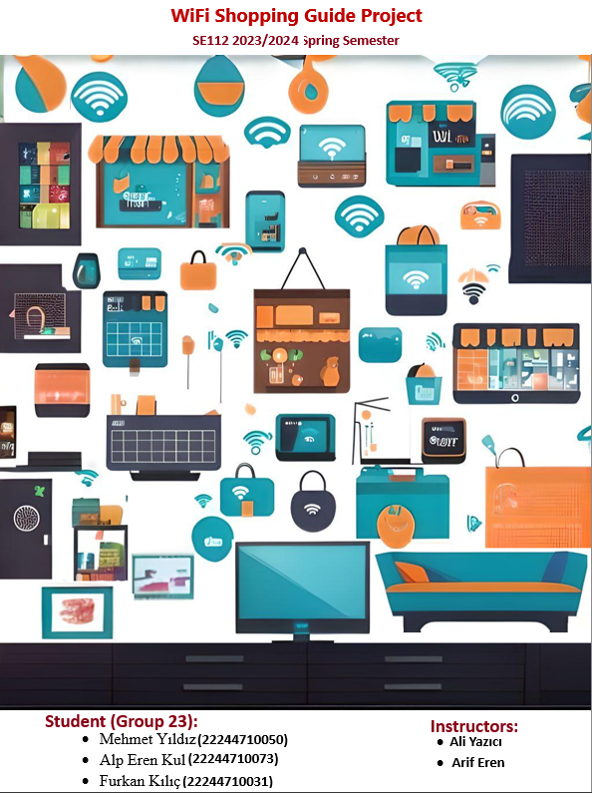

***ç***

# Contents:

WiFi Shopping Guide Project 3

Project Management: 4

Gantt Diagram: 5

Risk Plan: 5

Requirements: 6

User-story: 6

Use-Case Diagram: 7

PlantUML Script: 8

Class Diagram: 9

PlantUML Script: 10

Activity Diagram: 11

Mock-ups by Figma: 12

# WiFi Shopping Guide Project

The purpose of this application we created is to compare quality and affordable products in line with our users' requests online and offer the most suitable one to you.: WiFi Shopping Guide Project is a web-based and application design for the young and old alike shopping on the Internet. People will be able to see the quality of food and compare it. They will be able to see where it is cheaper or discounted. Apart from these, they will be able to easily place orders on this site. They will be able to purchase from our project, which is the most reliable, highest quality, suitable for our users, from the companies and supply providers in our own infrastructure, and in which we will assist our customer support team 24/7 in case of any problems. Our users can see the prices from both us and other companies. They can make their decisions. Our project takes the prices and quality of products from other companies for people, compares them with the products on our site and offers the most suitable one to the user Also agile software methodology will be used to develop this project.

# Project Management:

**Project Plan:**

|  |  |  |
| --- | --- | --- |
| ***TASK*** | **TIME{DAYS}** | ***PREDECESSORS*** |
| A. decide the requirements of the project | 7 | - |
| B. Defining the purpose | 4 | - |
| C. Task sharing with members | 2 | A |
| D. Budget planning | 4 | A,B |
| E. Risk planning | 5 | D |
| F. Starting the project | 3 | E |
| G. Bug checking and improvements | 4 | F |

# Gantt Diagram:

metin, çizgi, öykü gelişim çizgisi; kumpas; grafiğini çıkarma, ekran görüntüsü içeren bir resim

Açıklama otomatik olarak oluşturuldu

# Risk Plan:

|  |  |  |  |  |
| --- | --- | --- | --- | --- |
| **Risk Item** | **Impact** | **Action** | **Type** | **Risk Ratio (%)** |
| **group member leaving the group** | **Distribution of tasks** | **It can increase the work of group members, which causes deviation in the schedule.** | **High Risk** | **%11.4** |
| **The project is not completed on time** | **loss of popularity** | **If the project does not arrive on time, members may rush and make mistakes in the project.** | **Medium Risk** | **%7.7** |

# Requirements:

|  |  |  |
| --- | --- | --- |
| Functional Reqs ID | Explanation | MOSCOW priority (M, S, C, W) |
| FR1 | Remove of out of stock product | C |
| FR2 | Cart to add products | M |
| FR3 | Secure payment system | M |
| FR4 | Creating a receipt after purchase | S |
| FR5 | Registering and logging into the system | M |
| FR6 | User-friendly product display | S |
| FR7 | Easy product selection | S |
| FR8 | Product can be returned | S |
| FR9 | Notification about the status of received products | W |
| FR10 | User can give feedback | S |
| Non-Functional Reqs ID | Explanation | MOSCOW priortiy  (M, S, C, W) |
| NFR1 | Compatibility | C |
| NFR2 | Security | M |
| NFR3 | Performance | S |

# User-story:

The user logs into the system.Then, User can go to the section of the product user wants, see the stock status, and check the delivery time if user wants to see how many days it will arrive.If the desired stock status is met, it is optionally customized according to the user's wishes and the product delivery to the user begins. User relocation, product cancellation, product change, etc. If user has a request such as this, user can call the customer service and ask for whatever user wants.

# Use-Case Diagram:

metin, diyagram, çizim, çizgi içeren bir resim

Açıklama otomatik olarak oluşturuldu

# PlantUML Script:

@startuml

actor Customer

actor SearchEngine

actor SupportTeam

'top to bottom direction

'right to left direction

rectangle WifiGuideShopping{

usecase SearchSite

usecase BuyProducts

usecase Login

usecase FindMatchingProducts

usecase CustomerService

usecase CheckStock

usecase DeliveryTime

}

SearchEngine -- (FindMatchingProducts)

Customer -- (Login)

SupportTeam--(CustomerService)

(FindMatchingProducts) ..|> (CheckStock) : <<extend>>

(CheckStock) ..|> (DeliveryTime) : <<extend>>

(CheckStock) ..|> (SearchSite) : <<include>>

(SearchSite) ..|> (Login) : <<include>>

(BuyProducts) ..|> (SearchSite) : <<extend>>

(BuyProducts) ..|> (CustomerService) : <<extend>>

@enduml

# Class Diagram:

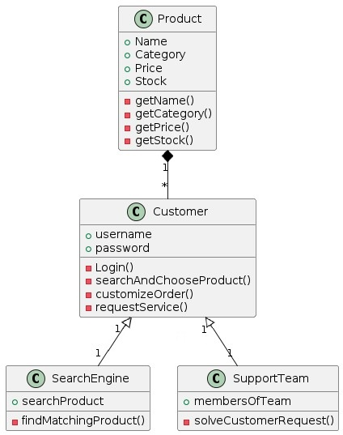

# PlantUML Script:

@startuml

class Product{

+ Name

+ Category

+ Price

+ Stock

- getName()

- getCategory()

- getPrice()

- getStock()

}

Product "1"--"*" Customer

class Customer{

+ username

+ password

- Login()

- searchAndChooseProduct()

- customizeOrder()

- requestService()

}

Customer "1"--"1" SearchEngine

Customer "1"--"1" SupportTeam

class SearchEngine{

+ searchProduct

- findMatchingProduct()

}

class SupportTeam{

+ membersOfTeam

- solveCustomerRequest()

}

@enduml

# Activity Diagram:

metin, ekran görüntüsü, diyagram, yazı tipi içeren bir resim

Açıklama otomatik olarak oluşturuldu

# Mock-ups by Figma:

